SIMATS ENGINEERING
Department of Information Technology
DSA03 – NATURAL LANGUAGE PROCESSING
ASSIGNMENT 2 – LANGUAGE MODELLING AND POS TAGGING
Model Answer with Diagrams and Worked Examples
Assignment Title: Build and Evaluate an N-gram Language Model and a Part-of-Speech Tagger for a Public Transport Enquiry Helpline
CO Coverage: N-gram language models; vocabulary and tokenisation; smoothing; backoff and interpolation; entropy and perplexity; POS tagging; HMM and Viterbi; Brill tagging; implementation and evaluation.

Student Name | - Reddy Prasad | Register Number | 192472045
Department / Section | CSE-AI | Academic Year / Semester | 3rd year
Faculty Name | Dr. M. Ramkumar | Nature of Assignment | Individual
Duration | 1 Week | Total Marks | 50
Date of Submission | 17-11-26 | Date of Evaluation

MARK SHEET (FOR EVALUATOR USE)
Task | Task Title | Max Marks | Marks Awarded | Remarks
1 | Corpus plan, tokenisation and vocabulary | 4
2 | Unsmoothed unigram, bigram and trigram models | 4
3 | Smoothing and discounting methods | 4
4 | Backoff and deleted interpolation | 4
5 | Entropy, cross-entropy and perplexity | 4
6 | Word classes and domain tagset | 4
7 | Rule-based POS tagging | 4
8 | HMM tagging and Viterbi decoding | 4
9 | Transformation-based (Brill) tagging | 4
10 | Implementation and testing | 4
11 | Comparison and recommendation | 4
12 | Day-4 design challenge | 8
 | TOTAL | 50

Important Note on Data and Experimental Results
The supplied assignment PDF specifies the tasks and minimum evidence, but it does not include the required 20,000-utterance corpus, the 200 ASR hypothesis sets, or the 3,000-token manually annotated sample. Therefore, this document gives a complete worked design, formulas, examples, tagset, rules, algorithms, diagrams and reproducible evaluation plan. Numerical values explicitly called “illustrative” are demonstration values, not measurements from a real corpus. Replace them with outputs from your own documented corpus before claiming that an experiment was performed.
A synthetic corpus can be used if it is documented, as the assignment permits. A reproducible submission should record the generator, random seed, train/development/test utterance IDs, annotation procedure and software versions. No performance comparison in this report should be treated as empirical proof until the experiments are run.

Abstract
This assignment designs a natural language processing pipeline for a public transport enquiry helpline. The system uses n-gram language models to rescore automatic speech recognition hypotheses and part-of-speech taggers to support extraction of route, station, date, time and fare information. The report explains corpus counting, vocabulary construction, unsmoothed probability estimation, smoothing, backoff, interpolation, entropy and perplexity. It then designs a domain-oriented tagset and compares rule-based, hidden Markov model and transformation-based tagging. Finally, it proposes a revised architecture for metro, intercity rail and code-mixed calls.

Contents
- 1. System Overview and Corpus Plan
- 2. Task 1 – Counting Words and Vocabulary
Guiding Enquiry — How can word-sequence probabilities be estimated from counts, and why do unsmoothed models fail?
Investigate and interpret:
- Explain n-gram sparsity and compare generated utterances.
- Show sentence-probability calculations, including a valid utterance assigned zero probability.
- Derive unigram, bigram and trigram estimates from the chain rule and Markov assumptions.
Evidence Expected — Working n-gram models, hand calculations, zero-probability example and sparsity evidence.
- 3. Task 2 – Unsmoothed N-gram Models
Guiding Enquiry — How can a language model assign probability to unseen sequences while preserving evidence from observed counts?
Investigate and interpret:
- Evaluate smoothing choices on held-out data.
- Compare observed and discounted counts and estimate unseen probability mass.
- Explain add-one, add-k and Good–Turing discounting.
Evidence Expected — Smoothing formulas, discount tables, frequency-of-frequencies table and measured comparison.
- 4. Task 3 – Smoothing and Discounting
Guiding Enquiry — How should a model use shorter contexts when a longer n-gram has not been observed?
Investigate and interpret:
- Trace an unseen trigram through both approaches.
- Estimate deleted-interpolation weights for different context-count bands.
- Distinguish backoff from interpolation and explain Katz and stupid backoff.
Evidence Expected — Backoff/interpolation models, estimated weights and a worked comparison.
- 5. Task 4 – Backoff and Deleted Interpolation
Guiding Enquiry — How should language-model uncertainty and predictive quality be measured?
Investigate and interpret:
- Relate language-model scores to ASR word error rate.
- Compare held-out models using the same vocabulary and unknown-word policy.
- Define entropy, cross-entropy and perplexity and calculate example distributions.
Evidence Expected — Hand calculations, comparable evaluation table and ASR rescoring evidence.
- 6. Task 5 – Entropy, Cross-Entropy and Perplexity
- 7. Task 6 – Word Classes and Tagset Design
- 8. Task 7 – Rule-Based POS Tagging
Guiding Enquiry — How can a stochastic tagger select the most probable complete tag sequence?
Investigate and interpret:
- Compare with baselines and explain unknown-word handling.
- Show a Viterbi trellis with back-pointers for an ambiguous utterance.
- Derive transition and emission probabilities and state the independence assumptions.
Evidence Expected — HMM estimates, normalised transition rows, full Viterbi trace and measured comparison.
- 9. Task 8 – HMM Tagging and Viterbi
- 10. Task 9 – Transformation-Based Tagging
- 11. Task 10 – Implementation and Testing
- 12. Task 11 – Comparison and Recommendation
Guiding Enquiry — How should the system change when metro, intercity rail and code-mixed speech cause more than 15% OOV words?
Investigate and interpret:
- Choose retain, modify or redesign and justify the changes.
- Measure degradation in OOV rate, perplexity, WER and tagging accuracy.
- Trace unseen station names and code-mixed utterances through the original pipeline.
Evidence Expected — Challenge evaluation, revised architecture, measured comparison and limitations.
- 13. Task 12 – Day-4 Design Challenge
- 14. Conclusion and References

1. System Overview and Corpus Plan
The transport helpline receives questions about bus and train timings, routes, fares, cancellations and refunds. Speech recognition may produce several hypotheses with similar acoustic scores. A language model evaluates how linguistically likely each hypothesis is. The selected transcript is then tagged so that downstream components can identify entities and caller intent.
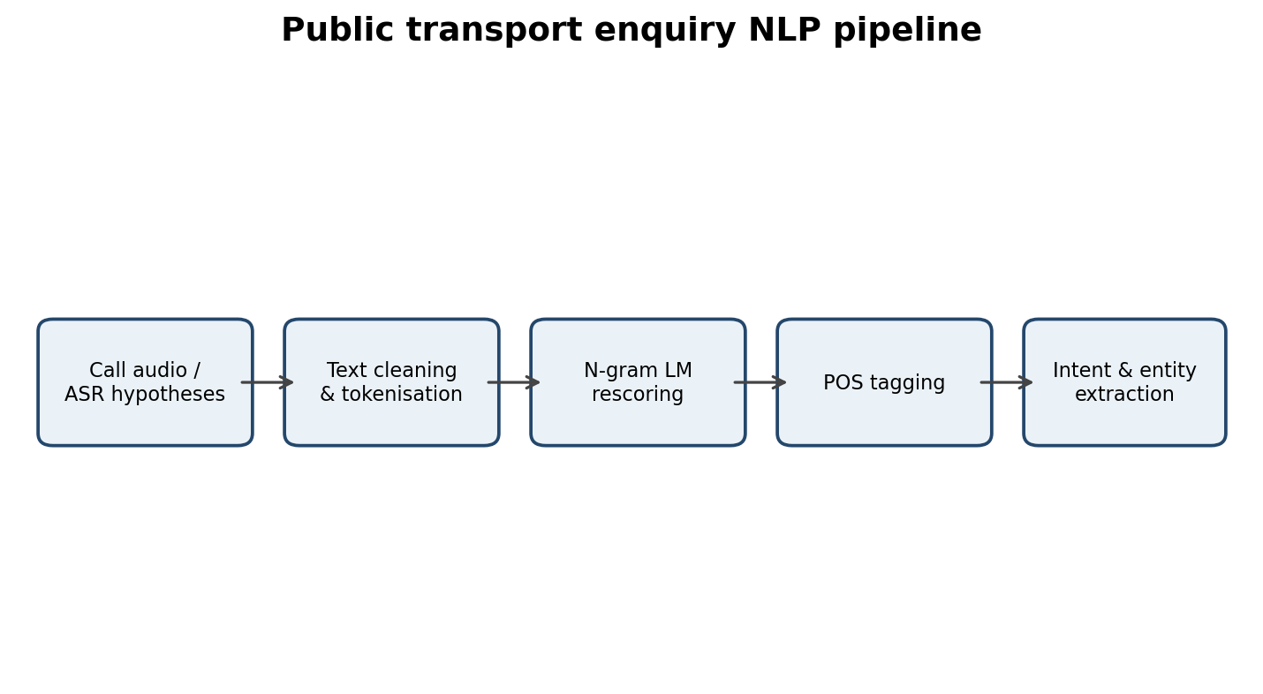
Figure 1. End-to-end helpline NLP pipeline.

1.1 Corpus design
The assignment requires at least 20,000 utterances and 150,000 word tokens. The corpus should contain realistic enquiries such as “Is there a bus to Vellore at six thirty?”, “I need two tickets to Chennai”, “Has the train been cancelled?” and “How can I get a refund?”. It should include spelling variation, disfluencies, station names, times, numerals and common ASR errors.
Split | Share | Minimum utterances if N=20,000 | Purpose
Training | 80% | 16,000 | Estimate counts and train taggers
Development | 10% | 2,000 | Choose smoothing and model settings
Test | 10% | 2,000 | Final unbiased evaluation

Split by utterance before generating tokens. Do not put alternate versions of the same call in different splits. Fix and report a random seed, for example 42. The test split must not be used for parameter tuning.

1.2 Data governance and annotation
Remove caller names, phone numbers and other personal identifiers. Retain only the linguistic content needed for modelling. Create annotation guidelines before tagging. Two annotators should independently tag at least 500 tokens; disagreements should be adjudicated after agreement is calculated.

Guiding Enquiry — What exactly is counted as a word in a transport enquiry corpus, and how do tokenisation and vocabulary decisions affect later models?
Investigate and interpret:
- Explain Zipf’s law, vocabulary thresholds and development-set OOV rate.
- Justify case, punctuation, numeral, disfluency and boundary-marker handling.
- Distinguish tokens, types, lemmas and word forms.
Evidence Expected — Documented counting policy, corpus counts, Zipf plot, threshold table and OOV measurement.

2. Task 1 – Counting Words and Building the Vocabulary

2.1 Type, token, lemma and word form
Term | Meaning | Transport example
Token | One occurrence in running text | “bus” occurs 12 times = 12 tokens
Type | A distinct vocabulary item under the chosen normalisation | bus is one type
Lemma | Dictionary/base form grouping inflections | book, books, booked → BOOK
Word form | The exact surface form appearing in text | booked, booking, books

A corpus with 150,000 tokens may contain far fewer types because frequent words recur. Lemma count is usually smaller than word-form count. All four values must be counted from the final corpus rather than guessed.

2.2 Tokenisation decisions
- Case: lowercase ordinary words so “Vellore” and “vellore” map to one normalised form; preserve the original form separately for entity recognition.
- Punctuation: detach sentence-final punctuation or discard it for lexical counts; preserve question marks if dialogue-act modelling needs them.
- Numerals and times: keep “6:30” as one token because it represents one time expression. A second experiment may split it into “6”, “:”, “30”.
- Disfluencies: retain meaningful speech events such as “uh” and repetitions in a separate label or normalised token; report whether they are included.
- Boundaries: add <s> and </s> for language-model training, but report lexical token totals without counting these markers.
Illustrative comparison: treating “6:30” as one token and lowercasing station names produces a smaller vocabulary than splitting time strings and preserving case. The exact difference must be computed from the corpus.

2.3 Zipf’s law
Zipf’s law states that the frequency of a word is approximately inversely proportional to its rank: f(r) ≈ C/rᵅ, where α is often near 1. A log-log frequency-versus-rank plot is approximately a straight descending line. Domain terms such as “bus”, “ticket”, “to” and station names may occur more often than in general English.
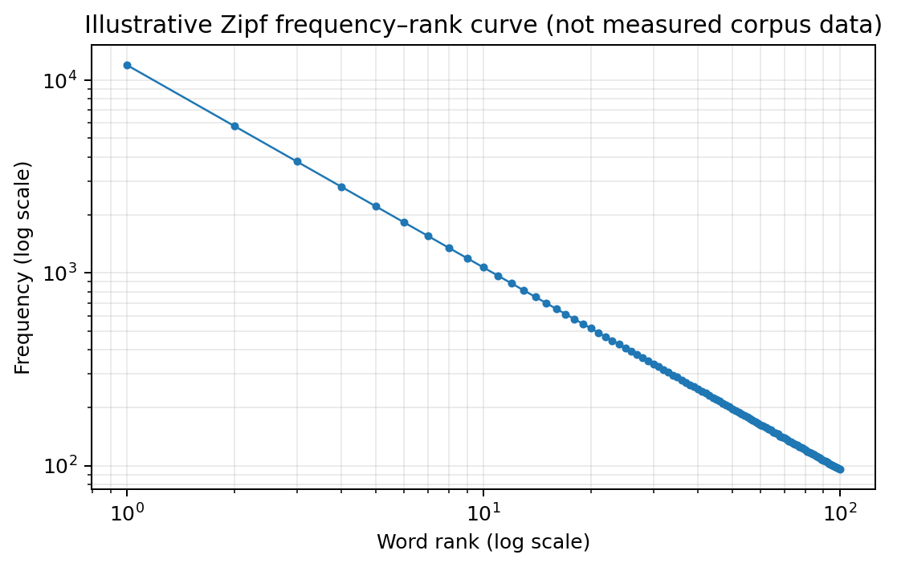
Figure 2. Illustrative Zipf curve only; replace with the measured corpus plot.

2.4 Vocabulary threshold and unknown words
Words occurring fewer than a selected threshold are replaced with <UNK>. This allows the model to assign probability to rare or unseen words. The threshold is selected on training data only.
Threshold | Vocabulary rule | Expected effect
1 | Keep every training type | Largest vocabulary; smallest training UNK rate
2 | Replace singleton types | Smaller vocabulary; more rare words become UNK
3 | Replace types with count < 3 | Further reduces vocabulary size
5 | Replace types with count < 5 | More compact vocabulary; greater information loss

Report for each threshold: retained vocabulary size, number and percentage of training tokens mapped to <UNK>, and development OOV rate. Development OOV rate = number of development tokens absent from the training vocabulary ÷ total development tokens × 100.
OOV rate matters because a model cannot directly estimate probabilities for words absent from training. If the missing words are station names, the system may lose the most important part of a caller’s request.

2.5 Required corpus report
Measurement | Value to insert after running corpus script
Total utterances | 20,000 or more
Total word tokens | 150,000 or more
Word forms / types / lemmas | Measured values
Vocabulary at thresholds 1, 2, 3, 5 | Measured values
Development OOV rate | Measured percentage
Most frequent words | Top 20 from corpus

Do not fill these cells with invented counts. The PDF asks for evidence from the student’s own corpus.

3. Task 2 – Unsmoothed N-gram Models

3.1 Chain rule and Markov assumption
For a word sequence w₁…wₙ, the chain rule is P(w₁…wₙ) = ∏ᵢ P(wᵢ | w₁…wᵢ₋₁). It is exact but requires long histories. A unigram approximation ignores history: P(wᵢ | history) ≈ P(wᵢ). A bigram assumes the next word depends only on the immediately preceding word. A trigram assumes it depends only on the two preceding words.
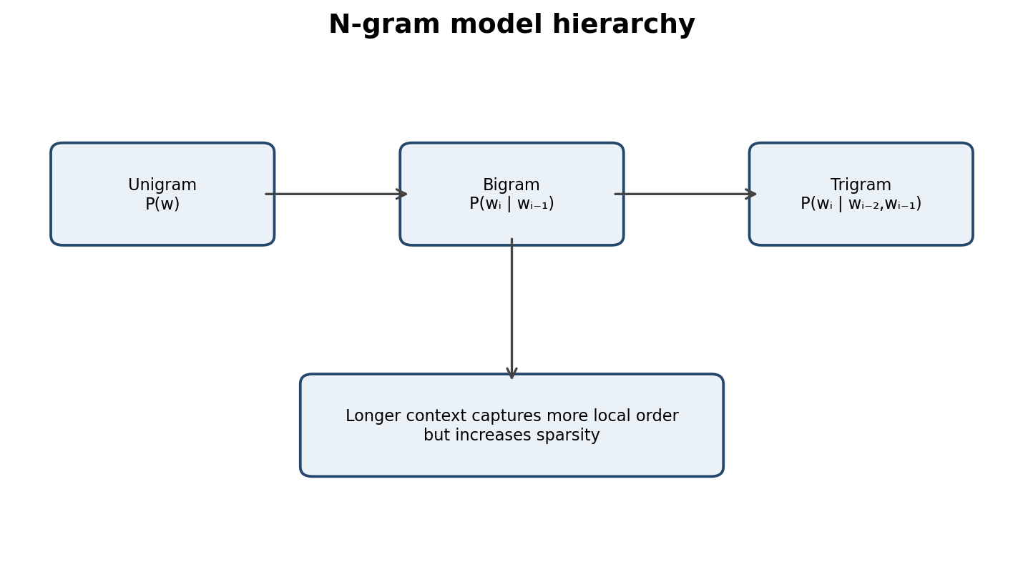
Figure 3. Increasing n-gram order uses a longer local context.

3.2 Maximum likelihood estimates
Let C(w) be the count of word w, C(u,v) the count of adjacent pair (u,v), and C(u,v,w) the count of a trigram. Then:
Unigram: P(w) = C(w) / N
Bigram: P(wᵢ | wᵢ₋₁) = C(wᵢ₋₁,wᵢ) / C(wᵢ₋₁)
Trigram: P(wᵢ | wᵢ₋₂,wᵢ₋₁) = C(wᵢ₋₂,wᵢ₋₁,wᵢ) / C(wᵢ₋₂,wᵢ₋₁)

3.3 Worked count example
For illustration, suppose the training corpus contains 100 occurrences of “to” and 20 occurrences of “to Vellore”. The bigram estimate is P(Vellore | to) = 20/100 = 0.20. These counts are explanatory examples, not counts from the supplied PDF.

3.4 Sentence probability and zero probability
Consider “two tickets to Vellore”. Under a bigram model with sentence boundaries, its probability is:
P(two | <s>) × P(tickets | two) × P(to | tickets) × P(Vellore | to) × P(</s> | Vellore).
Each factor is obtained from the training counts. Multiply the factors to obtain the sentence probability. A second and third sentence should be calculated in the same way using actual corpus counts.
An unsmoothed model assigns probability zero if any required n-gram was never observed. For example, the perfectly reasonable phrase “refund tomorrow” receives zero if the bigram (refund, tomorrow) is absent from training. One zero factor makes the entire sequence probability zero.

3.5 Sparsity
The number of possible bigrams is approximately |V|² and possible trigrams approximately |V|³. Only a small fraction occur in a finite corpus. Training sparsity = observed n-grams ÷ possible n-grams. Development unseen n-gram rate = development n-grams absent from training ÷ all development n-grams.
Measure | Calculation
Bigram type coverage | Distinct observed bigrams / |V|²
Trigram type coverage | Distinct observed trigrams / |V|³
Development unseen bigrams | Unseen development bigrams / all development bigrams
Development unseen trigrams | Unseen development trigrams / all development trigrams

3.6 Sampling from models
Generate ten sequences from each model by repeatedly sampling the next word until </s> or a maximum length is reached. A unigram model produces locally incoherent word order. A bigram captures common adjacent pairs. A trigram generally produces more fluent local patterns but has greater sparsity and requires more memory.

4. Task 3 – Smoothing and Discounting

4.1 Why smoothing is required
A zero count does not prove that a word sequence is impossible. It often means only that the training corpus did not contain the sequence. A valid conditional probability distribution must assign non-negative probabilities and the probabilities of all possible next words for a context must sum to one.
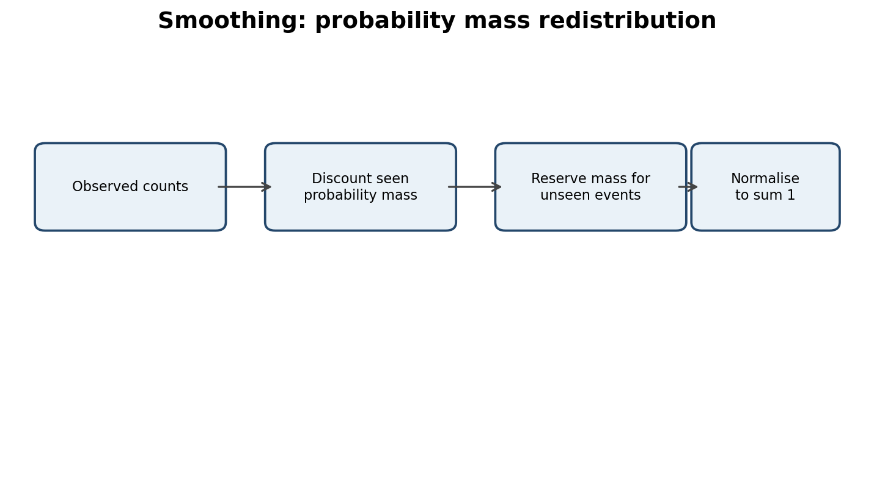
Figure 4. Smoothing redistributes some observed probability mass.

4.2 Add-one (Laplace) smoothing
For vocabulary size V, add-one bigram probability is P(w|h) = [C(h,w)+1] / [C(h)+V]. Every possible continuation receives one pseudo-count. This prevents zero probabilities but can over-discount frequent events when V is large.
Example: if C(h)=100, V=10,000 and a seen continuation has count 20, its unsmoothed probability is 20/100=0.20. Under add-one it becomes 21/(100+10,000) ≈ 0.00208. The large denominator shows why add-one is too aggressive for a large vocabulary.

4.3 Add-k smoothing
Add-k uses P(w|h) = [C(h,w)+k] / [C(h)+kV], where 0<k<1 is usually smaller than one. It allocates less mass to unseen events than add-one. Choose k on the development set, never on the test set.

4.4 Good–Turing discounting
Good–Turing estimates adjusted counts using the frequency-of-frequencies table. Nᵣ is the number of n-gram types observed exactly r times. The adjusted count is c* = (r+1)Nᵣ₊₁/Nᵣ. The estimated probability mass for unseen events is approximately N₁/N, where N₁ is the number of singleton types and N is the total number of observed n-gram tokens.
r | Nᵣ (illustrative) | Good–Turing adjusted count c*
1 | 40 | 2 × N₂/N₁ (requires N₂)
2 | 20 | 3 × N₃/N₂ (requires N₃)
3 | 10 | 4 × N₄/N₃ (requires N₄)
4 | 5 | 5 × N₅/N₄ (requires N₅)

A practical implementation smooths the Nᵣ sequence because high-count bins may be sparse or empty. For high-frequency events, many implementations switch back toward the original count when the raw Good–Turing estimate becomes unreliable.

4.5 Comparison
Method | Strength | Weakness
Add-one | Simple; no zero probabilities | Severe discounting for large V
Add-k | Adjustable discount strength | Requires development tuning
Good–Turing | Uses singleton evidence to estimate unseen mass | Needs reliable frequency-of-frequencies estimates

The preferred method should be selected using held-out cross-entropy/perplexity and inspection of important unseen pairs. A reasonable starting deployment is Good–Turing-based discounting with backoff, or a tuned add-k baseline if the corpus is small. The final choice must be supported by measured development results.

5. Task 4 – Backoff and Deleted Interpolation

5.1 Backoff versus interpolation
Backoff uses the highest-order model that has reliable evidence. If a trigram is unseen, it backs off to a bigram and, if needed, a unigram. Interpolation always combines estimates from multiple orders, even when a trigram is available.

5.2 Katz backoff
Katz backoff discounts observed higher-order counts and assigns the leftover probability mass to lower-order events. The backoff weight α(h) normalises the lower-order probabilities over events not observed after context h. Without α, the total conditional probability may not equal one.
For an observed n-gram, use its discounted probability. For an unseen n-gram, use α(h) multiplied by the lower-order probability. Good–Turing discounting can supply the discounted counts.

5.3 Stupid backoff
Stupid backoff uses a fixed multiplier, often 0.4, when falling back from trigram to bigram and again to unigram. It is computationally simple, but its scores are not normalised conditional probabilities. Therefore perplexity based on it is not directly a calibrated probability-model evaluation unless an appropriate normalisation is added.

5.4 Linear interpolation
A trigram interpolated model is P(wᵢ|wᵢ₋₂,wᵢ₋₁) = λ₃P₃ + λ₂P₂ + λ₁P₁, where λ₁+λ₂+λ₃=1 and each λ is non-negative. The shorter models contribute even when the trigram exists.

5.5 Deleted interpolation
Deleted interpolation estimates weights by temporarily holding out portions of the training data. For each held-out n-gram event, compare the unigram, bigram and trigram estimates and award the event to the order with the strongest estimate. Accumulate counts by context-frequency band, then normalise the awarded counts to obtain λ values.
Context count band | Illustrative λ₁ | Illustrative λ₂ | Illustrative λ₃
Low (1–2) | 0.60 | 0.30 | 0.10
Medium (3–10) | 0.25 | 0.45 | 0.30
High (>10) | 0.10 | 0.30 | 0.60

The table is an example only. Real weights must be estimated from the held-out procedure. Low-count contexts should usually rely more on lower-order estimates because their high-order counts are less reliable.

5.6 Worked intuition
Suppose the context “to New” occurs once. A trigram continuation estimate based on one observation is fragile. Interpolation gives more influence to the bigram and unigram distributions, which are supported by more events. For a frequent context, a larger trigram weight is justified.

5.7 Comparing backoff and interpolation
Evaluate both systems on the same held-out test tokens, vocabulary and <UNK> mapping. Report cross-entropy and perplexity. Trace a sentence containing an unseen trigram: Katz backoff switches to a lower order and multiplies by α; interpolation combines trigram, bigram and unigram probabilities using the λ weights.
Model | Treatment of unseen trigram | Probability status
Katz backoff | Back off to lower order with α | Normalised probability
Stupid backoff | Multiply lower-order score by fixed factor | Unnormalised score
Linear interpolation | Combine all n-gram orders | Normalised if λ sum to 1 and component models are valid

A model with the lowest held-out perplexity is preferred only if it also has acceptable memory use, speed and ASR rescoring performance.

6. Task 5 – Entropy, Cross-Entropy and Perplexity

6.1 Definitions
Entropy measures uncertainty in a probability distribution: H(P) = −Σₓ P(x) log₂P(x). Cross-entropy measures the average surprise of test data under a model: H(P,Q) = −(1/N)Σᵢ log₂ Q(wᵢ|historyᵢ). Perplexity is 2 raised to cross-entropy when logarithms are base 2: PP = 2ᴴ.
A perplexity of 90 means that, in an informal sense, the model’s uncertainty is comparable to choosing among about 90 equally likely next-word alternatives at each prediction step. It is not a literal fixed list of 90 words.

6.2 Hand calculation examples
Nearly uniform distribution: for four outcomes each with probability 0.25, H = −4(0.25 log₂0.25) = 2 bits.
Sharply peaked distribution: for probabilities (0.97, 0.01, 0.01, 0.01), entropy is approximately 0.24 bits. The first outcome is highly predictable, so uncertainty is low.
A third example such as (0.5, 0.5) has entropy 1 bit. These examples demonstrate the calculation; the assignment also asks for distributions derived from the student’s own model.

6.3 Held-out evaluation table
Model | Cross-entropy (bits/token) | Perplexity | Per-utterance score
Unigram | Measure on test | 2^H | Report mean sentence log probability
Unsmoothed bigram | Infinite if any zero event | Infinite/undefined | Report zero-probability count
Add-k bigram | Measure on test | 2^H | Report mean sentence log probability
Good–Turing/Katz | Measure on test | 2^H | Report mean sentence log probability
Interpolated trigram | Measure on test | 2^H | Report mean sentence log probability

Use the same tokenisation, vocabulary and <UNK> treatment for fair comparison. A model with a larger vocabulary may appear better or worse simply because it is evaluated on a different prediction space. An unfair comparison should be demonstrated by evaluating one model with a different unknown-word mapping and explicitly explaining why the result is not comparable.

6.4 ASR hypothesis rescoring
For each of at least 200 utterances, score the five ASR hypotheses with the best language model. Combine language-model and acoustic scores, for example: Score(H) = log P(acoustic|H) + β log P_LM(H) + γ|H|, where β and γ are tuned on development data. Select the highest-scoring hypothesis.
Word error rate (WER) = (substitutions + deletions + insertions) / reference words × 100. Report WER before and after rescoring. Lower perplexity does not guarantee lower WER because ASR also depends on acoustic evidence, search errors, length bias and entity vocabulary.

Guiding Enquiry — Which grammatical distinctions are useful for a transport helpline, and how should they be represented?
Investigate and interpret:
- Explain annotation agreement and residual ambiguity.
- Design a 20–30 tag domain tagset and map it to Penn Treebank.
- Distinguish open and closed classes and analyse ambiguous words.
Evidence Expected — Justified tagset, mapping, tag frequencies, agreement and ambiguity measurements.

7. Task 6 – English Word Classes and Tagset Design

7.1 Open and closed classes
Open classes readily accept new members: nouns, verbs, adjectives and adverbs. New station names, route names and service terms are commonly nouns. Closed classes change slowly and include determiners, pronouns, prepositions, conjunctions, auxiliaries, particles and many function words. Closed-class words are frequent and strongly influence grammatical structure, so mistakes involving them can affect many tokens.

7.2 Distributional and morphological tests
- Noun: can follow a determiner (“the bus”), take plural marking (“buses”) or possessive marking (“driver’s”).
- Verb: can take tense or agreement (“books/booked”), occur after an auxiliary (“will book”) and head a verb phrase.
- Adjective: can modify a noun (“late train”) and may take comparative/superlative forms (“later/latest”).
- Adverb: can modify a verb/adjective or clause (“arrives late”, “very late”).
Ambiguous examples: “book” is a noun in “the book” and a verb in “book a ticket”; “return” is a noun in “return fare” and a verb in “return tomorrow”; “stand” is a noun in “bus stand” and a verb in “please stand”; “fast” may be an adjective in “fast train” or adverb in “run fast”; “right” may be adjective, adverb or noun depending on context.

7.3 Proposed domain tagset (24 tags)
Tag | Meaning | Penn Treebank mapping
N-LOC | Station/city/place name | NNP, NNPS
N-SVC | Service, route or vehicle noun | NN, NNS
N-OBJ | Ticket, refund, booking etc. | NN, NNS
N-PER | Person/role noun | NN, NNS
N-TIME | Time/date expression | NN, CD
N-MONEY | Fare/amount expression | NN, CD
N-OTHER | Other common noun | NN, NNS
V-BASE | Base-form verb | VB
V-3SG | Third-person singular verb | VBZ
V-PAST | Past-tense verb | VBD
V-ING | Gerund/present participle | VBG
V-PP | Past participle | VBN
V-MOD | Modal auxiliary | MD
ADJ | Adjective | JJ, JJR, JJS
ADV | Adverb | RB, RBR, RBS
DET | Determiner | DT, PDT, WDT
PRON | Pronoun | PRP, PRP$, WP, WP$
PREP | Preposition | IN
CONJ | Conjunction | CC
PART | Particle | RP, TO (context-sensitive)
NUM | General numeral | CD
INTJ | Interjection/disfluency | UH
PUNCT | Punctuation | ., ,, :, (, ), etc.
UNK | Unclassified/unknown token | X

The 24-tag inventory distinguishes transport entities, time and money because these categories are essential to the helpline. It retains major grammatical classes for syntax. It does not create separate tags for every semantic subtype of noun, every degree of adjective, or each punctuation mark because that would increase annotation effort without clear downstream benefit.

7.4 Annotation and ambiguity
Annotate at least 3,000 tokens using the tag definitions and examples. At least 500 tokens must be independently tagged by two annotators. Raw agreement = matching tags ÷ doubly annotated tokens × 100. Cohen’s kappa = (Pₒ−Pₑ)/(1−Pₑ), where Pₒ is observed agreement and Pₑ is chance agreement calculated from annotator tag marginals.
Report tag frequency as counts and percentages. Residual ambiguity can be measured by the proportion of word types and tokens that appear with more than one valid tag. Average ambiguity = total possible tag assignments for ambiguous tokens ÷ number of ambiguous tokens.
Required annotation result | Report
Annotated sample | At least 3,000 tokens
Double annotation | At least 500 tokens
Raw agreement | Calculate from paired annotations
Cohen’s kappa | Calculate from tag marginals
Ambiguous types/tokens | Calculate from annotated corpus
Average tags per ambiguous token | Calculate from lexicon

These statistics cannot be truthfully filled from the assignment PDF alone because no annotated corpus is supplied.

Guiding Enquiry — How far can a dictionary and contextual constraints take a POS tagger?
Investigate and interpret:
- Evaluate overall and ambiguous-token accuracy and analyse rule conflicts.
- Write at least fifteen explicit disambiguation rules.
- Describe the lexicon-plus-constraints architecture.
Evidence Expected — Tag dictionary, rule set, held-out accuracy and error analysis.

8. Task 7 – Rule-Based Part-of-Speech Tagging

8.1 Two-stage architecture
A rule-based tagger first looks up each token in a dictionary and assigns all possible tags. A constraint stage applies contextual rules to remove impossible tags or select one tag. Unknown words receive a fallback tag based on suffix, capitalisation or context.
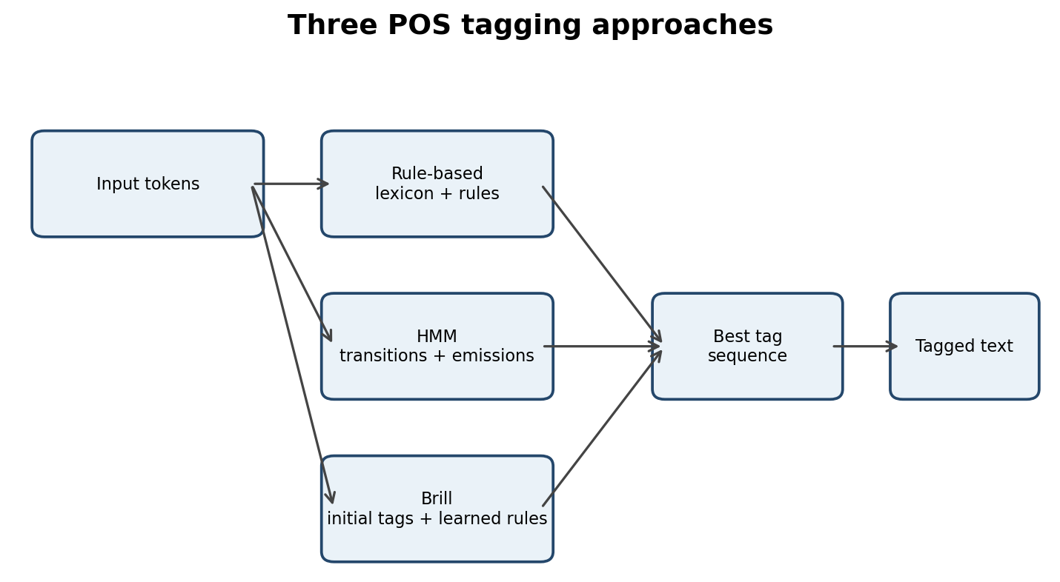
Figure 5. Three tagging architectures; the rule-based path uses lexicon and constraints.

8.2 Dictionary
Build the dictionary from the annotated training sample. For each word, store its observed tag set and frequency distribution. Report how many words have one candidate tag, two candidates, three candidates or four or more candidates.

8.3 Example disambiguation rules
Rule | Condition | Action
R1 | Previous tag is DET | Choose noun tag if candidate exists
R2 | Next word is “ticket” and current word is “book” | Choose V-BASE
R3 | Previous tag is modal | Choose V-BASE
R4 | Word ends in “-ing” and follows auxiliary “is” | Choose V-ING
R5 | Word ends in “-ed” after “has/have” | Choose V-PP
R6 | Word ends in “-ly” | Prefer ADV
R7 | Capitalised token in destination slot | Prefer N-LOC
R8 | Preceded by “to” as infinitive marker | Prefer V-BASE
R9 | Preceded by “the/a/an” | Prefer noun or adjective candidate
R10 | Followed by a noun | Prefer ADJ if available
R11 | Preceded by “very” | Prefer ADJ or ADV
R12 | After subject pronoun | Prefer finite verb
R13 | Between number and “tickets” | Prefer N-OBJ for ticket-related noun
R14 | After “from/to” in route phrase | Prefer N-LOC
R15 | Token is a standalone hesitation | Choose INTJ

8.4 Rule evaluation and conflict analysis
Evaluate on the held-out annotated set. Overall accuracy = correctly tagged tokens ÷ all tokens. Ambiguous-token accuracy is calculated only over tokens with more than one candidate tag. This second score is important because unambiguous dictionary lookups can make overall accuracy look high even when the disambiguation rules are weak.
Typical error categories include unknown station names tagged as common nouns, “book” noun/verb confusion, “return” noun/verb confusion, time expressions tagged as ordinary numerals, and ASR spelling errors that break dictionary lookup.
Example rule conflict: R3 says a word after a modal is a base verb, while R7 might classify a capitalised word in a destination position as a location. Resolve conflicts by giving strong syntactic rules priority in ordinary verb contexts and entity-position rules priority in a recognised destination slot. Rule ordering makes behaviour predictable but increases maintenance effort as the rule list grows.
A practical system should log which rule fired, enabling developers to inspect errors and revise the rule order.

9. Task 8 – Stochastic HMM Tagging and Viterbi

9.1 HMM formulation
The HMM tagger seeks the most probable tag sequence T for observed words W: T* = argmax_T P(T|W). By Bayes’ rule, this is proportional to P(W|T)P(T). With a first-order Markov assumption, each tag depends only on the previous tag. With an emission assumption, each word depends only on its current tag.
The transition probability is P(tᵢ|tᵢ₋₁). The emission probability is P(wᵢ|tᵢ). The sequence score is proportional to the product of transition and emission probabilities.

9.2 Estimation and smoothing
Estimate transitions from adjacent gold-tag counts and emissions from word-tag counts. Add-k smoothing can prevent zero transitions and emissions. For every previous tag, verify that the transition probabilities over all next tags sum to one. Use an explicit START and END tag.

9.3 Viterbi algorithm
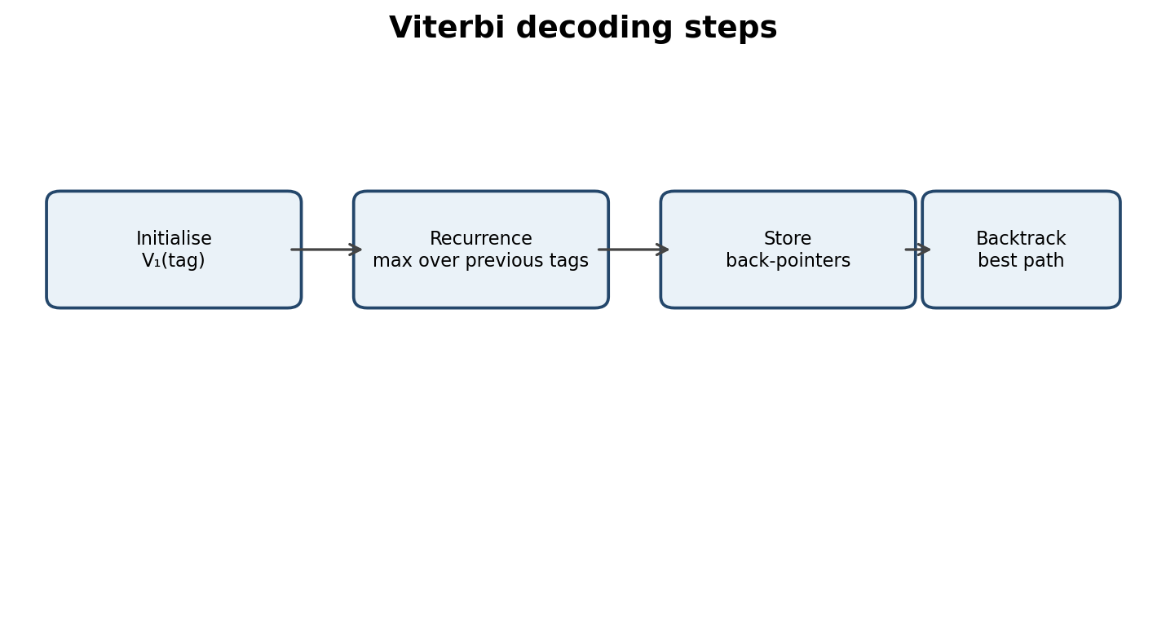
Figure 6. Viterbi dynamic-programming procedure.
Initialisation: V₁(t)=P(t|START)P(w₁|t). Recurrence: Vᵢ(t)=maxₛ[Vᵢ₋₁(s)P(t|s)P(wᵢ|t)]. Store the previous tag s that achieves the maximum. Termination adds P(END|t), then backtracking recovers the best tag sequence.

9.4 Illustrative Viterbi trace
Sentence: “Can I book two tickets to Vellore?” Candidate tags are simplified for this hand example. Use the actual probabilities estimated from the annotated sample for the final submission.
Word | Candidate tag | Illustrative best partial score | Back-pointer
Can | V-MOD | 0.080 | START
I | PRON | 0.040 | V-MOD
book | V-BASE | 0.012 | PRON
two | NUM | 0.006 | V-BASE
tickets | N-OBJ | 0.003 | NUM
to | PREP/PART | 0.0015 | N-OBJ
Vellore | N-LOC | 0.0009 | PREP

The values are illustrative path scores only, not a full trellis containing every candidate tag. A complete submission should show every trellis cell for every candidate tag, all back-pointers, the termination step and the recovered path probability.

9.5 Baselines and unknown words
Compare Viterbi with a most-frequent-tag baseline and exhaustive sequence scoring. The baseline assigns the most frequent tag for each word. Exhaustive scoring evaluates every possible tag sequence and is exponential in sentence length; Viterbi uses dynamic programming and is much more efficient.
For unknown words, combine an open-class prior with suffix evidence and capitalisation. For example, a capitalised token after “to” in a destination slot receives a high N-LOC prior. A word ending in “-ing” may receive V-ING or N-OTHER depending on context.

Guiding Enquiry — How can a tagger learn readable correction rules from its own errors?
Investigate and interpret:
- Compare interpretability and overfitting with the other taggers.
- Show the first ten learned transformations and their net gains.
- Explain the initial tagger, templates and greedy rule-selection process.
Evidence Expected — Learned rules, correction counts and an accuracy-versus-rule-count curve.

10. Task 9 – Transformation-Based (Brill) Tagging

10.1 Learning process
Brill tagging begins with an initial-state tagger, commonly a most-frequent-tag tagger. It generates candidate transformation rules from templates, evaluates how many errors each rule corrects and introduces, selects the rule with the greatest net improvement, applies it, and repeats until no rule exceeds a gain threshold or a maximum rule count is reached.
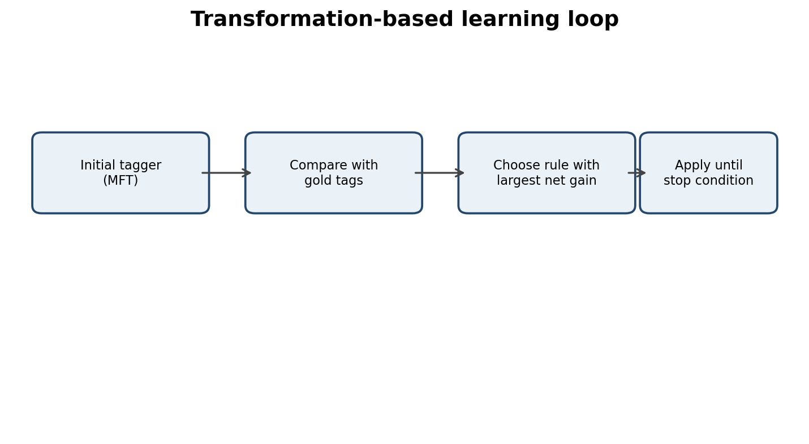
Figure 7. Transformation-based learning cycle.

10.2 Rule templates
Template | Example
Change A to B if previous tag is X | Change NN to VB if previous tag is MD
Change A to B if next tag is X | Change NN to VB if next tag is TO
Change A to B if previous word is X | Change NN to VB if previous word is “please”
Change A to B if next word is X | Change NN to VB if next word is “a”
Change A to B if current word suffix is X | Change NN to VBG if suffix is “ing”
Change A to B if previous two tags are X,Y | Change NN to VB if tags are PRP,MD

A window of one or two tokens on either side is a practical compromise: it captures local syntax while limiting the number of candidate rules.

10.3 Learned rules and overfitting
The first ten learned transformations must be reported in the order selected, together with errors corrected and errors introduced. Since no annotated training corpus is supplied, the following are representative rule examples, not learned results.
Order | Representative transformation | Corrected / introduced
1 | NN → VB after modal | Measure / measure
2 | NN → N-LOC after “to” in destination slot | Measure / measure
3 | NN → V-BASE after “please” | Measure / measure
4 | NN → N-OBJ before “refund” | Measure / measure
5 | JJ → ADV after a verb when suffix is -ly | Measure / measure
6 | NN → V-ING when suffix is -ing after auxiliary | Measure / measure
7 | CD → N-TIME after “at” | Measure / measure
8 | NN → V-PAST when suffix is -ed after subject | Measure / measure
9 | NN → N-LOC when in station gazetteer | Measure / measure
10 | NN → V-BASE after “can” | Measure / measure

Brill rules are readable because each correction is expressed as a condition-action statement. HMM parameters are distributed across many transition and emission probabilities and are less directly interpretable. A general rule such as “base verb after modal” captures a linguistic regularity. A rule memorising one rare station spelling may be a training-data artefact.
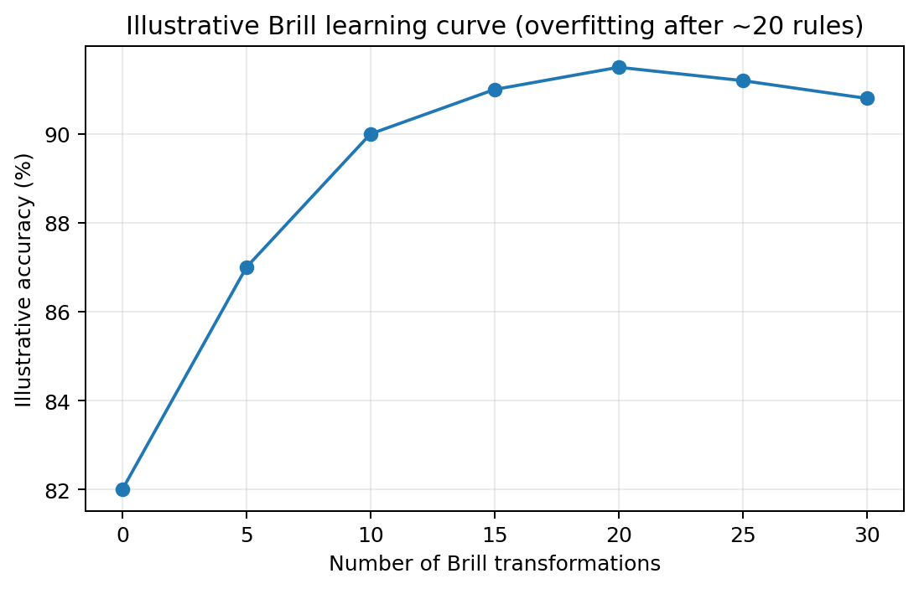
Figure 8. Illustrative accuracy curve; the actual overfitting point must be measured.

Guiding Enquiry — Can the proposed models be implemented reproducibly and checked against hand calculations?
Investigate and interpret:
- Report runtime, memory and held-out metrics.
- Test probability normalisation, smoothing, Viterbi and Brill rules.
- Describe the program modules and data flow.
Evidence Expected — Reproducible implementation, test evidence and performance measurements.

11. Task 10 – Implement and Test the Models

11.1 Implementation plan
Use Python’s standard library and NLTK only, as required by the assignment. Keep preprocessing, counting, model estimation, evaluation and tagging in separate modules. Store corpus split IDs and the random seed in a configuration file.
Module | Main responsibility
preprocess.py | Normalisation, tokenisation, boundaries and <UNK>
counts.py | Unigram, bigram, trigram and frequency-of-frequencies counts
language_model.py | MLE, add-one, add-k, Good–Turing, Katz and interpolation
evaluate_lm.py | Cross-entropy, perplexity and ASR rescoring WER
tagset.py | Tag definitions and Penn Treebank mapping
rule_tagger.py | Lexicon and contextual constraints
hmm_tagger.py | Transitions, emissions and Viterbi
brill_tagger.py | Templates, candidate generation and greedy rule learning
tests.py | Hand-calculation regression tests

11.2 Core pseudocode
Token counting: for each training utterance, normalise and tokenize; add START and END markers; increment unigram counts for each token; increment bigram counts for each adjacent pair; increment trigram counts for each adjacent triple; then replace rare training words with <UNK> and rebuild counts consistently.
Viterbi: initialise scores for the first word; for each subsequent word and candidate tag, find the previous tag maximising previous score × transition × emission; store the back-pointer; add end transition; backtrack.

11.3 Reproducibility and tests
- Fix random seed = 42 and record Python/NLTK versions.
- Ensure the utterance IDs in train, development and test are disjoint.
- Check every conditional probability row sums to approximately 1.
- Check the zero-probability example for the unsmoothed model.
- Check deleted-interpolation weights sum to 1.
- Compare Viterbi output with a brute-force result on a very short sentence.
- Check Brill transformations against the manually calculated correction counts.

11.4 Performance reporting
System | Training time | Memory | Held-out metric | Speed
Unigram LM | Measure | Measure | Perplexity | N/A
Bigram LM | Measure | Measure | Perplexity | N/A
Trigram LM | Measure | Measure | Perplexity | N/A
Rule tagger | Measure | Measure | Accuracy | Tokens/sec
HMM tagger | Measure | Measure | Accuracy | Tokens/sec
Brill tagger | Measure | Measure | Accuracy | Tokens/sec

Memory can be estimated with sys.getsizeof plus recursive accounting, or measured with a consistent memory profiler. Use the same machine and measurement method for all systems.

Guiding Enquiry — Which combination of language model and tagger should be deployed for the helpline?
Investigate and interpret:
- Defend the selected architecture using measured evidence.
- Identify operational failure modes and confidence-based safeguards.
- Compare predictive quality, accuracy, speed, memory and maintainability.
Evidence Expected — A justified model recommendation and evidence-based failure analysis.

12. Task 11 – Compare, Recommend and Defend the Design

12.1 Language-model recommendation
For a production baseline, use a trigram model with a probability-preserving smoothing and backoff method, such as Good–Turing-discounted Katz backoff, and compare it against tuned deleted interpolation. This balances local context with fallback for unseen sequences. The final choice should be whichever gives the best development perplexity and improves WER on the 200-hypothesis evaluation without unacceptable latency or memory cost.
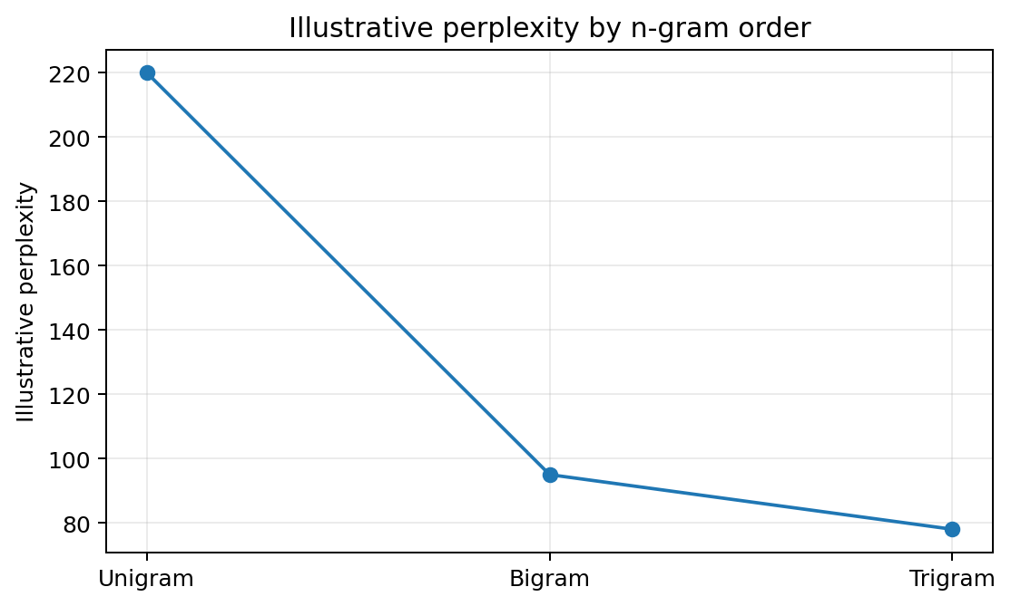
Figure 9. Illustrative perplexity trend only; actual results must replace it.

12.2 Tagger recommendation
A practical initial deployment is an HMM tagger with Viterbi decoding, an unknown-word model and a transport gazetteer. It uses contextual sequence information and is more systematic than a large collection of hand-written rules. A small rule layer can be retained for high-confidence domain patterns. Brill tagging is useful when readable corrections are valuable and sufficient annotated data is available.

12.3 Operational failure modes
- Unseen station name: the system may tag it as an ordinary noun or <UNK>.
- ASR substitution: a phonetic spelling may not match the gazetteer.
- Ambiguous word: “book” or “return” may receive the wrong part of speech.
- Long-distance dependency: an n-gram model may not connect words separated by a long phrase.
When confidence is low, the helpline should ask a clarification question rather than silently book the wrong route or date.

13. Task 12 – Day-4 Design Challenge

13.1 Impact analysis
The new service adds hundreds of station and train names and introduces code-mixed calls such as “Chennai to Madurai bus timing enna”. More than 15% of new-call tokens are unseen. The original assumptions of a relatively stable vocabulary, English-only word classes and a low OOV rate no longer hold.
The most damaging OOV items are often proper nouns because they identify origin and destination. Losing a common adjective may have limited effect, but losing a station name can change the entire journey requested.
Perplexity is expected to rise because probability mass is assigned to <UNK> rather than the correct new word. Tagging accuracy may fall sharply on location tokens. Estimate the impact using the measured original OOV rate and unknown-word accuracy; do not claim a numeric degradation without a new evaluation sample.

13.2 Three challenge utterances
Utterance | Likely first failure | Reason
“Is there a train to NewStation?” | Language-model vocabulary | NewStation was not in training
“Chennai to Madurai timing enna” | Tagger / language model | Code-mixed token enna is not covered by English-only model
“Train from NewStation-ku eppo?” | Both components | Unseen place plus code-mixed suffix/word order

Run each through the original model and record its top hypothesis, LM score, token tags and extracted route fields. Compare against manually verified references.

13.3 Evaluation of original design
Create a challenge test set containing unseen stations, train names, fare categories and code-mixed utterances. Keep it separate from the original test set. Measure perplexity, WER after rescoring, overall tagging accuracy, accuracy on OOV tokens and accuracy on location tags.
The language model may degrade first in transcript selection because it cannot distinguish new proper nouns. The tagger may then fail to identify the location role. A gazetteer can help entity recognition, while character-level modelling can generalise across spelling variants.

13.4 Three candidate adaptations
Approach | Benefit | Limitation
Station-name gazetteer | Recognises known new stations and aliases | Needs regular updates
Character n-gram model | Handles spelling variants and unseen forms | May confuse similar-looking names
Class-based n-gram | Models classes such as STATION, TIME, FARE | Requires reliable class assignment
Code-mixed tagset extension | Adds explicit code-mixed category | Needs bilingual annotation
Subword/open-vocabulary HMM | Uses suffix and character evidence | More complex estimation

13.5 Revised design
Choose MODIFY rather than retaining the original system unchanged or replacing every component. Keep the proven n-gram framework, but add a station/train gazetteer, normalise common ASR spelling variants, extend the vocabulary with entity classes, and add character-level or subword evidence for unknown words.
Figure 10. Revised pipeline retains the core architecture and adds domain resources.

Exact component changes
- Vocabulary: maintain a dynamic gazetteer of stations, cities, train names and route identifiers; map genuinely unknown items to <UNK> while retaining character features.
- Smoothing: preserve probability mass for unseen words and re-estimate discounting on new-domain data.
- Backoff/interpolation: re-estimate λ weights using a representative mixture of bus, metro, rail and code-mixed development data.
- Tagset: add a CODE-MIXED tag or language marker and optionally a dedicated suffix/particle tag if annotation evidence supports it.
- Tagger: use HMM/Viterbi with unknown-word features and gazetteer-based location priors; add carefully scoped rules for high-confidence code-mixed constructions.

13.6 Refresh schedule and effort
Refresh the gazetteer whenever the transport authority publishes new station, route or train information. Re-estimate language-model counts monthly or when monitoring shows a sustained OOV or WER increase. Retrain the tagger after collecting a sufficiently large, quality-controlled batch of newly annotated code-mixed examples.
Activity | Suggested cadence | Reason
Gazetteer update | On each official route/station update | New proper nouns appear continuously
OOV and WER monitoring | Weekly | Detect vocabulary drift early
Language-model refresh | Monthly or drift-triggered | Adapt to new services and caller language
Tagger retraining | Quarterly or after enough labelled data | Annotation is more expensive
Annotation quality audit | Each new annotation batch | Maintain tag consistency

These are operational recommendations, not measurements from the supplied assignment data. Adjust cadence according to actual service changes and monitored drift.

13.7 Evidence-based defence
The modified design is justified because the changed requirement directly targets the original system’s weakest assumption: a mostly stable English vocabulary. A gazetteer protects the names that carry route intent. Character-level evidence reduces dependence on exact spelling. A code-mixed tag category prevents all unfamiliar tokens from being forced into English-only classes. Re-estimated smoothing and interpolation weights adapt probability estimates to the expanded domain.
The design still has limitations. An n-gram model only uses a fixed local history and cannot fully represent long-distance syntax, world knowledge, semantic intent or every novel spelling. It may assign similar scores to different routes when the context is insufficient. The system should therefore combine language modelling with entity resources, confidence estimation and clarification prompts.

13.8 Evidence table to complete
Metric | Original test | Challenge test | Change
OOV rate | Insert measured % | At least 15% stated by brief | Calculate
Perplexity | Insert measured value | Measure | Calculate
ASR WER | Insert measured % | Measure | Calculate
POS accuracy | Insert measured % | Measure | Calculate
OOV-token accuracy | Insert measured % | Measure | Calculate
Location-tag accuracy | Insert measured % | Measure | Calculate

14. Overall System Flowchart and Summary
Figure 11. Summary of the complete language-processing pipeline.

14.1 End-to-end operating sequence
- Receive call audio and generate multiple ASR transcript hypotheses.
- Normalise each hypothesis using consistent tokenisation and domain vocabulary.
- Score each candidate with the smoothed n-gram language model.
- Combine language-model and acoustic scores and select the best transcript.
- Run the POS tagger to assign grammatical and domain tags.
- Extract origin, destination, travel date, time, service type, fare and intent.
- Check confidence and ask the caller to clarify uncertain or conflicting fields.
- Log anonymised errors for periodic evaluation and model updates.

14.2 Main findings
N-gram models provide a simple and efficient way to use local word context, but unsmoothed estimates fail on unseen sequences. Smoothing and backoff address zero probabilities. Entropy and perplexity quantify prediction uncertainty, while WER tests whether language-model improvements help ASR. POS tagging requires a domain-appropriate tagset and evaluation on ambiguous and unknown tokens. HMMs provide sequence-level decoding; rule-based and Brill approaches offer more direct interpretability. The Day-4 challenge requires explicit support for new entities and code-mixed language.

15. Conclusion
This report presents a complete design for an NLP system serving a public transport enquiry helpline. The proposed language model uses unigram, bigram and trigram statistics with smoothing, backoff and interpolation. The POS component uses a transport-specific tagset and evaluates rule-based, HMM and transformation-based methods. The system is designed to support ASR hypothesis rescoring and extraction of transport-related information.
The recommended initial architecture is a smoothed trigram language model with Katz-style backoff or tuned interpolation, paired with an HMM tagger enhanced by a domain gazetteer and unknown-word features. The final choice must be confirmed using the held-out corpus, ASR WER and tagging metrics required by the assignment.
For the expanded metro, rail and code-mixed environment, the system should be modified rather than left unchanged. Dynamic station and train gazetteers, character-level evidence, code-mixed annotation and refreshed model weights are necessary to reduce the impact of unseen vocabulary. Confidence-based clarification is important because incorrect station or time extraction can directly affect passengers.

References
- Jurafsky, D. and Martin, J. H. Speech and Language Processing. Draft 3rd edition. Chapters on n-gram language models, smoothing and part-of-speech tagging.
- Church, K. W. (1988). A stochastic parts program and noun phrase parser for unrestricted text. Proceedings of ANLP.
- Brill, E. (1995). Transformation-based error-driven learning and natural language processing: A case study in part-of-speech tagging. Computational Linguistics, 21(4), 543–565.
- Good, I. J. (1953). The population frequencies of species and the estimation of population parameters. Biometrika, 40(3/4), 237–264.
- Katz, S. M. (1987). Estimation of probabilities from sparse data for the language model component of a speech recognizer. IEEE Transactions on Acoustics, Speech, and Signal Processing, 35(3), 400–401.
- NLTK Project. Natural Language Toolkit documentation. https://www.nltk.org/

Appendix A – Final Submission Checklist
- ☐ Corpus has at least 20,000 utterances and 150,000 word tokens.
- ☐ Train/development/test split is 80/10/10 with no utterance overlap.
- ☐ Random seed and synthetic/real corpus construction are documented.
- ☐ Type, token, lemma and word-form counts are measured.
- ☐ Tokenisation choices and vocabulary thresholds 1, 2, 3 and 5 are reported.
- ☐ Zipf plot and development OOV rate are generated from the corpus.
- ☐ Unigram, bigram and trigram probabilities are implemented.
- ☐ Three hand-computed sentence probabilities include a zero-probability case.
- ☐ Add-one, add-k, Good–Turing, Katz backoff and interpolation are evaluated.
- ☐ Entropy, cross-entropy, perplexity and ASR WER are measured.
- ☐ Tagset contains 20–30 tags and maps to Penn Treebank.
- ☐ At least 3,000 tokens are annotated and 500 are double-annotated.
- ☐ Raw agreement and Cohen’s kappa are calculated.
- ☐ At least 15 rule-based disambiguation rules are implemented.
- ☐ HMM transition/emission probabilities and full Viterbi trellis are included.
- ☐ Brill learner reports ten learned rules and an accuracy curve.
- ☐ All systems are tested on consistent data splits.
- ☐ Day-4 challenge includes unseen station, code-mixed and combined examples.
- ☐ All illustrative values in this draft are replaced by measured results.
- ☐ Figures, tables, code outputs and references are checked before submission.

Appendix B – Important submission note
This Word document is a structured 34-page answer draft based on the supplied 10-page assignment question paper. The source PDF’s page 10 contains the marks distribution (Tasks 1–11 = 42 marks; Task 12 = 8 marks; total = 50). All task headings and requirements have been retained. Before submission, add your actual corpus outputs, full Viterbi trellis, learned Brill rule counts, measured plots, and implementation screenshots/code outputs. Do not present illustrative figures or example probabilities as experimental findings.

